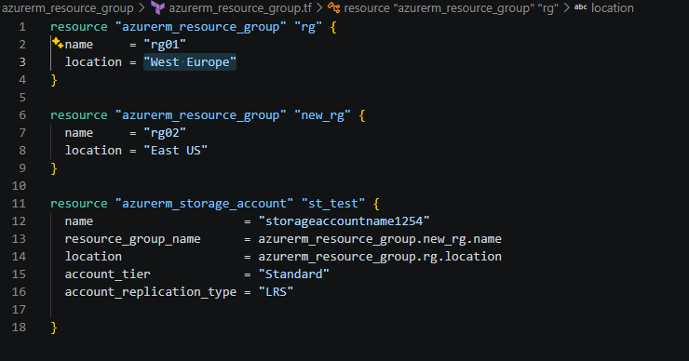

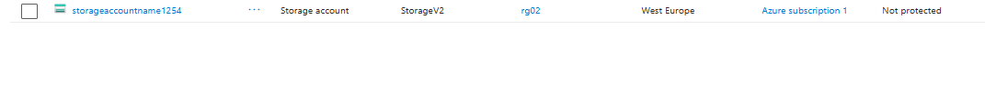

Haan bhai, yahin main confusion hai 😄. Screenshot mein actually 2 Resource Groups banaye gaye hain:
resource "azurerm_resource_group" "rg" {
name = "rg01"
location = "West Europe"
}

resource "azurerm_resource_group" "new_rg" {
name = "rg02"
location = "East US"
}
Ab neeche Storage Account dekho:
resource "azurerm_storage_account" "st_test" {
name = "storageaccountname1254"
resource_group_name = azurerm_resource_group.new_rg.name
location = azurerm_resource_group.rg.location
}

Yahan kya ho raha hai?
Storage Account kis Resource Group mein jaayega?
resource_group_name = azurerm_resource_group.new_rg.name
new_rg = rg02
aur rg02 ki location = East US
So Storage Account rg02 (East US) Resource Group ke andar create hoga.
Lekin uski location kya hai?
location = azurerm_resource_group.rg.location
rg = rg01
aur rg01 ki location = West Europe
So yahan Storage Account ko West Europe location di ja rahi hai.

Toh kya Resource Group aur resource ki location alag ho sakti hai?
Haan. Resource Group ki location aur uske andar resource ki location technically alag concepts hain. Azure resource group ek logical container hai; resources ko supported Azure regions mein deploy kiya ja sakta hai. Terraform examples bhi resource ke resource_group_name aur location ko separately specify karte hain. GGitHub+1
Is code ka conceptual structure:
RG01
└── location = West Europe

RG02
└── location = East US
└── Storage Account
└── location = West Europe
But bhai, screenshot wala code confusing hai aur likely teaching example mein jaan-bujhkar/reference samjhane ke liye aisa likha gaya hai. Normal practice mein same RG ki location ko resource ke location ke saath use karna common hai:
resource "azurerm_storage_account" "st_test" {
name = "storageaccountname1254"
resource_group_name = azurerm_resource_group.new_rg.name
location = azurerm_resource_group.new_rg.location
account_tier = "Standard"
account_replication_type = "LRS"
}
Ab dono:
Resource Group = rg02
RG Location = East US

Storage Account = rg02 ke andar
Storage Location = East US
Microsoft ke current Terraform example mein bhi Storage Account ka resource_group_name aur location same Resource Group ke attributes se reference kiya gaya hai. MMicrosoft Learn

Ek line mein yaad rakh:
resource_group_name batata hai "kis RG ke andar?"
location batata hai "resource kis Azure region mein?"
Isliye ye dono same hona zaroori nahi hai.
Agar tu chahe toh main screenshot ki har line ko beginner level pe rg.name, rg.location, .name, .location ka meaning ekdum simple diagram se samjha deta hoon.

Explicitly Dependency -
